34.109: The near point is at infinity, so that is where the image must be found for any objects that are close. So:
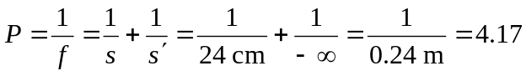 diopters.

